**Course: Advance Bio Informatics**

**Module Title: Introduction of Hidden Markov Models**

**Module No: 101**

**Hidden Markov Models**

Statistical Markov model is that in which the system being modeled is assumed to be a Markov process with unobserved (*hidden*) states.

**Statistical Models**

Any mathematical construct that attempts to parameterize a random process.

**Example:** A normal distribution

Assumptions

Parameters

Estimation

Usage

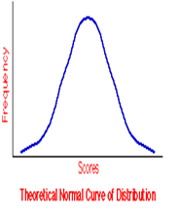

**History of HMM**

Leonard E. Baum 1960s mid-1970s: SR: words represented by the sound wave 1980s: biological sequences

**Definition**

A formal foundation for making probabilistic models of linear sequence labeling problems.

They provide a conceptual toolkit for building complex models just by drawing an intuitive picture.

**Formalism**

Statistical techniques for modeling patterns in data

First order Markov property-memory lessness



State generally a hidden entity which spawns symbols or features. Same symbol could be emitted by several states.

**HMMs**

N states, S1,S2,...Sn

Discrete time steps

t=0 t=1

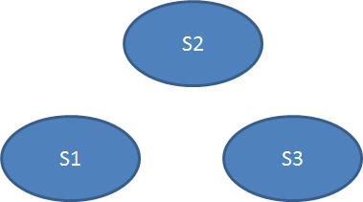

N = 3

t = 0